2022 CALIFORNIA CATTLEMEN’S ASSOCIATION
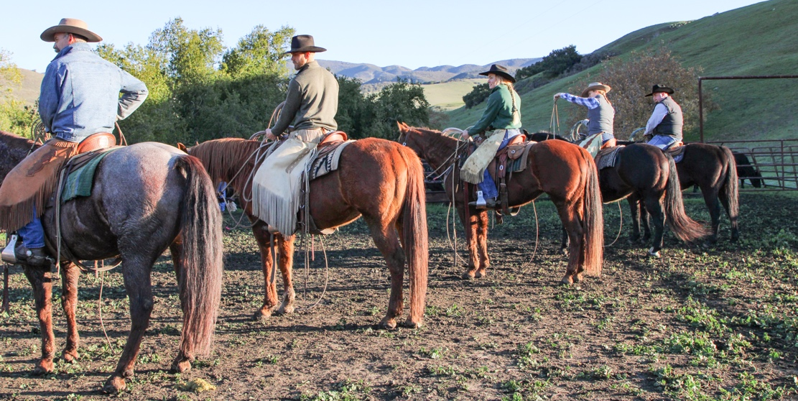

SCHOLARSHIP APPLICATION
CCA Allied Industry Scholarship • CCA Feeder Council Scholarship
- Tom Grimmius Memorial Scholarship • Terry Bengard Memorial
Scholarship • The Al Burtis Memorial Scholarship • Hank Stone Memorial California Beef Cattle Improvement Association Scholarship • Livestock Memorial Research Fund Scholarship

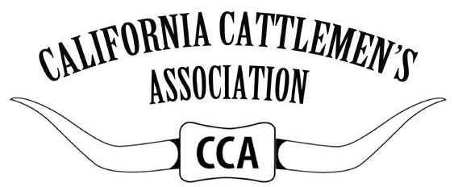

2022 CCA SCHOLARSHIP PROCESS
In 2021, CCA awarded $63,000 in scholarships to students studying agriculture. Scholarship amounts and quantities vary year to year and recipients of the CCA scholarship program can re-apply the following year. By filling out the CCA standard scholarship application, you will be considered for any of the following scholarships (so long as you meet the requirements).

Applications must be typed and returned in full to the California Cattlemen’s Association office by Saturday, October 1, 2022, at 11:59pm PST via email to Maureen at maureen@calcattlemen.org. Application materials must be combined into one PDF document to be accepted.

Applications will be pre-screened based on the criteria required and finalists will be contacted to schedule an interview with the selection committee. In order to receive a scholarship, applicants must be interviewed.

2022 SCHOLARSHIP OFFERINGS:

The Al Burtis Memorial Scholarship: Family, friends and colleagues of Al Burtis will award $2,000 to an outstanding student who has plans of working in sales and marketing in the industry through the CCA Allied Industry.

CCA Allied Industry Scholarship: Due to the outstanding support of the CCA Allied Industry Council, scholarship assistance is available to students currently enrolled in higher education.

CCA Feeder Council Scholarship: With special assistance and the generosity of Allflex, USA and the California Cattlemen’s Association Feeder Council, CCA is pleased to offer scholarships to students planning to enter a career with a beef cattle orientation.
Available 2022 scholarships continued on page 3.
2022 CCA SCHOLARSHIP PROCESS
Hank Stone Memorial California Beef Cattle Improvement Association Scholarship: The outstanding support of the California Beef Cattle Improvement Association (CBCIA) has made available scholarship assistance to students interested in beef cattle genetics and/or breeding. Students applying should demonstrate a continuing interest in beef cattle.

Terry Bengard Memorial Scholarship: Vintage Angus Ranch established this scholarship in 2020. The Bengard Family wishes to provide a $5,000 scholarship to a student currently enrolled in U.C. Davis School of Veterinary Medicine, U.C. Davis School of Law, or other post-graduate studies within the College of Agriculture and Environmental Sciences at U.C. Davis. The scholarship will be awarded to a student who has demonstrated a desire to work for or assist producers in the beef cattle industry in California.

Tom Grimmius Memorial Scholarship: The family of the late Tom Grimmius will award this annual $2,500 scholarship to an outstanding college student who has plans of working in the beef industry as a producer. This scholarship began in 2013.

Livestock Memorial Research Fund Scholarship: The Livestock Memorial Research Fund (LMRF) has provided exceptional scholarship assistance to students currently enrolled in veterinary or other upper division and post-graduate coursework. This scholarship is not awarded each year, but only when an exceptional candidate is identified. The scholarship began in 2018. Only upper division and post-graduate applicants will automatically be eligible for the award.

2022 SCHOLARSHIP APPLICATION REQUIREMENTS
- Applicant must be a young, regular or feeder member of the California Cattlemen’s Association. No exceptions. If you are not a member, join at www.calcattlemen.org/join or call the CCA office at (916) 444-0845.

- Applicant must be a current undergraduate, master, school of law or veterinary student attending or enrolled in a junior college, four-year college, university or law school (high school students are not eligible). Those currently holding upper division status or enrolled in post-graduate programs will be automatically applied for the LMRF Scholarships. No additional application or supplemental items are required.

- Applicants must have graduated from a California high school or be an out-of- state student currently attending a California college in order to apply.

- Applicant must have a cumulative grade point average of at least 3.0 on a four-point scale.

- Applicant must be studying a major consistent with career goals and should be planning a career associated with the beef cattle industry. This can include, but is not limited to, cattle production, genetics, nutrition, trade, law, agricultural communications, agricultural education, marketing, lending, policy, etc.

- A typed 1,000-word or less statement outlining career goals and the purpose for applying for a scholarship must be included. Applicant should cite all activities that demonstrate leadership qualities, intellectual growth and breadth of interests.

- Applicant must be available for a virtual or in person interview on Tuesday, Nov. 29, 2022, at the Nugget Casino Resort in Sparks, Nevada during the CCA & CCW Annual Convention. In person interviews are encouraged, but virtual interviews will be available for those who cannot attend in person.

- A letter of recommendation from a faculty member of the applicant’s current school and a letter of recommendation from one other person of the applicant's choosing must be included. Letters from family members will not be accepted.

- A copy of the applicant’s current transcripts must also be included indicating academic status and major (if enrolled in college). Transcripts need not be official. Unofficial transcripts obtained from the school’s student website or other student portals will be accepted.

2022 CCA SCHOLARSHIP APPLICATION FORM
Applications must be typed and returned in full to the California Cattlemen's Association office by Saturday, October 1, 2022 at 11:59pm PST via email to Maureen LaGrande at maureen@calcattlemen.org.
1. CONTACT INFORMATION

First Name Last Name

Phone Number Email Address

Home Mailing Address City/ State/ZIP

Date of Birth (MM/DD/YYYY) Cumulative GPA

Name of college or university you currently attend

Major or Course of Study

For the following three questions: select the correct box, right click, select “format shape” and fill the box with a solid color or highlight the answer.
Classification in Fall 2022
Undergraduate
Graduate
Veterinary
Other

Class Standing in Fall 2022
Freshman
Sophomore
Junior
Senior
Other

Are you a past recipient?
Yes, I am.
No, I am not.

2. TOP ACCOMPLISHMENTS
Please list your top four accomplishments you consider most valuable to the 2022 CCA scholarship application.

1.

2.

3.

4.

3. EDUCATION
Please include high schools, junior colleges and colleges attended with dates of attendance and graduation (including your present school). Do NOT include single course or class studies; e.g. night school.

SCHOOL NAME, CITY | YEARS ATTENDED | MAJOR/ MINOR | GPA | DEGREE
High School
Junior College
College
College

4. WORK EXPERIENCE
Please list your work experience during the past four years starting with your most recent job.

COMPANY NAME | POSITION | DUTIES | HOURS/ WEEK | DATES EMPLOYED

5. APPLICANT SIGNATURE
The undersigned hereby certifies that the information provided in this application is true and complete.

Failure to adhere to any of the previous requirements may result in a disqualification of the application. It is the responsibility of the applicant to ensure that all information is provided. The CCA office will not contact applicant regarding any missing information.

Please note that supplemental materials included with scholarship applications will not be used in the selection of scholarship recipients. Only the materials outlined in this application will be accepted for consideration.

Applicant Name Applicant Signature Date (MM/DD/YYYY)

2022 CCA SCHOLARSHIP APPLICATION CHECKLIST

I am a current CCA member. To become a member or renew your membership, please call the CCA office at (916) 444-0845 or do it online at www.calcattlemen.org/join.

I have typed and signed my completed application.

I have attached the following completed application materials as ONE PDF document in an email to maureen@calcattlemen.org. Note: students who submit applications as multiple files and not one PDF will be asked to resubmit.
A completed application.

A 1,000 word or less typed statement outlining career goals and the purpose for applying, citing all activities that demonstrate leadership qualities, intellectual growth and breadth of interests.

Two letters of recommendation: one from a faculty member from my current school and one from another person of my choosing who is not a family member. Letters of recommendation may be sent separately if requested by the letter author.

A copy of my current transcripts (unofficial is accepted), indicating academic status and major.

I have made sure I am available to participate in a phone or virtual interview on Tuesday, November 29, 2022, if selected.

I have submitted my completed application by the deadline of Saturday, October 1, 2022 at 11:59pm PST.

Good luck, applicants!

Application Questions? Visit calcattlemen.org/scholarship and read the frequently asked questions or contact Maureen LaGrande at maureen@calcattlemen.org or at (916) 444-0845.

