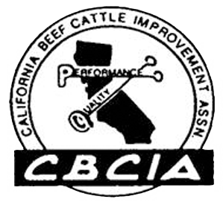
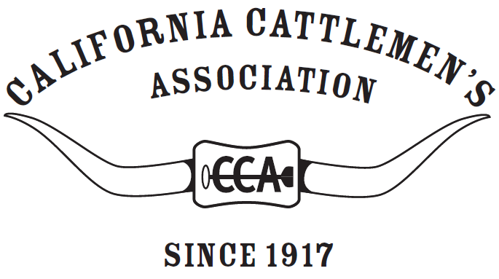

Carcass of Merit Gold
certificate is presented to

NAME

whose market beef animal meets the standard of yield and quality
established by CBCIA and was shown at the
Month Year Name Fair in Town, California
 | Carcass of Merit | Gold Seal Carcass | Name – Ear Tag# Merge
Hot Carcass Weight, lb. | 600-950 | 650-900 | Merge HCW Field
USDA Quality Grade, min. | Choice- | Choice | Merge QG written field
USDA Yield Grade | Lower than 3.0 | 2.5 or lower | Merge YG Field

