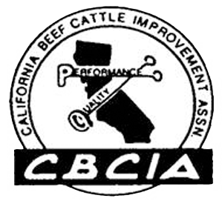
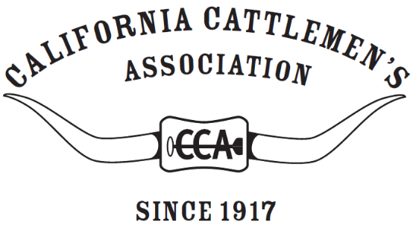

Gold Carcass of Merit
certificate is presented to

<<NAME>>

whose market beef animal meets the standard of yield and quality
established by CBCIA and was shown at the
<< YEAR>> <<FAIR NAME>>, <<TOWN>>, Calif.
 | Carcass of Merit | Gold Seal Carcass | Ear Tag #
Hot Carcass Weight, lb. | 600-1000 | 650-900
USDA Quality Grade | Choice- or higher | Choice average or higher
USDA Yield Grade | Below 4.0 | Below 3.0

